Please use this form to record your Safeguarding concern | 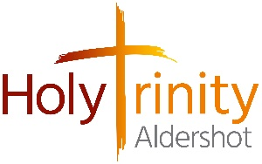
When completed, please send this form to our Holy Trinity Safeguarding Officers, Fay Hampshire and Jocelyn King at htcasafeguarding@gmail.com You can send a photograph of the completed form, use the scanner in the church office or hand the form directly to either Fay or Jocelyn.
Please print clearly:
Name of person reporting a safeguarding concern
Phone number of person reporting a safeguarding concern
Position held within Holy Trinity Church, if applicable
Name of person for whom a Safeguarding concern has been raised
When was this Safeguarding concern raised? You must give day, date and time
Give a brief, but detailed, description of the observation or disclosure, including the current risk
When and where did this happen?
Action taken by the person reporting this concern

The following section is to be completed by the HT Safeguarding Officer:
Action taken by the HTA parish Safeguarding Officer
Date reported to the Diocesan Safeguarding Adviser (DSA) – REQUIRED – Must be actioned.
Case Reference Number ( provided by Diocesan Safeguarding Adviser, DSA)
Is the Parish satisfied with the response from the Diocesan Safeguarding Adviser, DSA?
Is there considered to be a continuing risk? It might be pertinent to give details and reasons

